Wazuh File Integrity Monitoring :
Why we are changing because by default the agent will share the logs information after 12hours.
Therefore we need to change for real time logs.
We need to do some changing in file C:\Program Files (x86)\ossec-agent/ossec.conf
First open your notepad as an Administrator :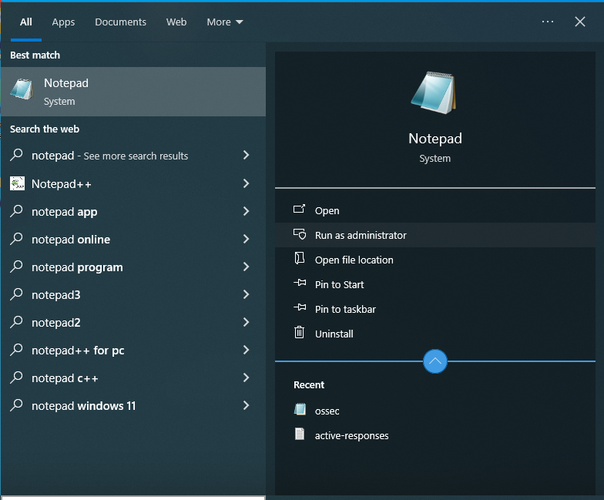
Click on yes. It will open’s your notepad then on the top left side click on file then open and navigate to : C:\Program Files (x86)\ossec-agent/ossec.conf
If you don’t find the file there then remove the filter of txt :
Click on Text Document and then select All files.
Now scroll down and find ossec.conf and open it!
When the file opens then press Ctrl+F and find : syscheck
And past the following command :
<directories check_all="yes" realtime="yes">C:\Users\Administrator\Documents</directories>
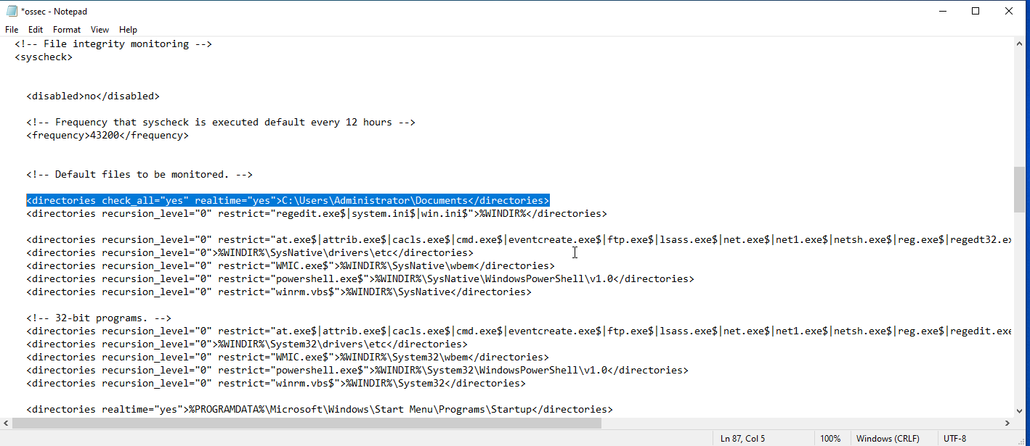
Know Save the file and restart the wazuh agent in windows by powershell. Open the Powershell as an Administrator and run the following command : Restart-Service -Name wazuh

Know check the service is running or not past the following command : get-service -Name wazuhsvc

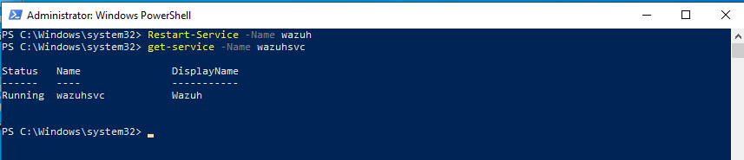

Now Restart your system and it’s done.

